SITE PHOTOS

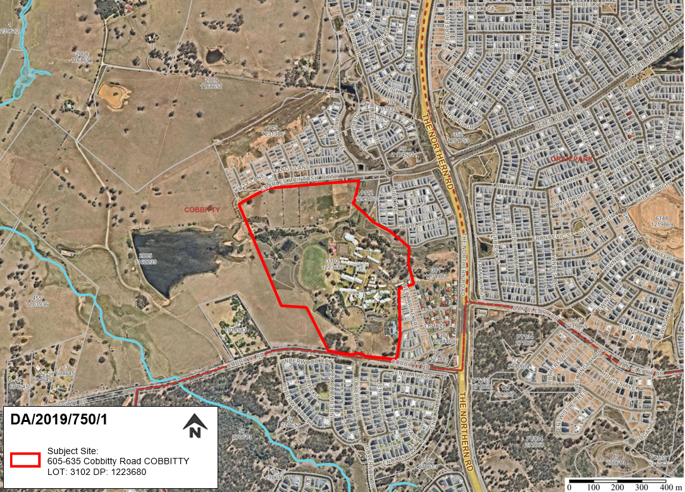

Figure 1: Aerial photo with the site outline in red.
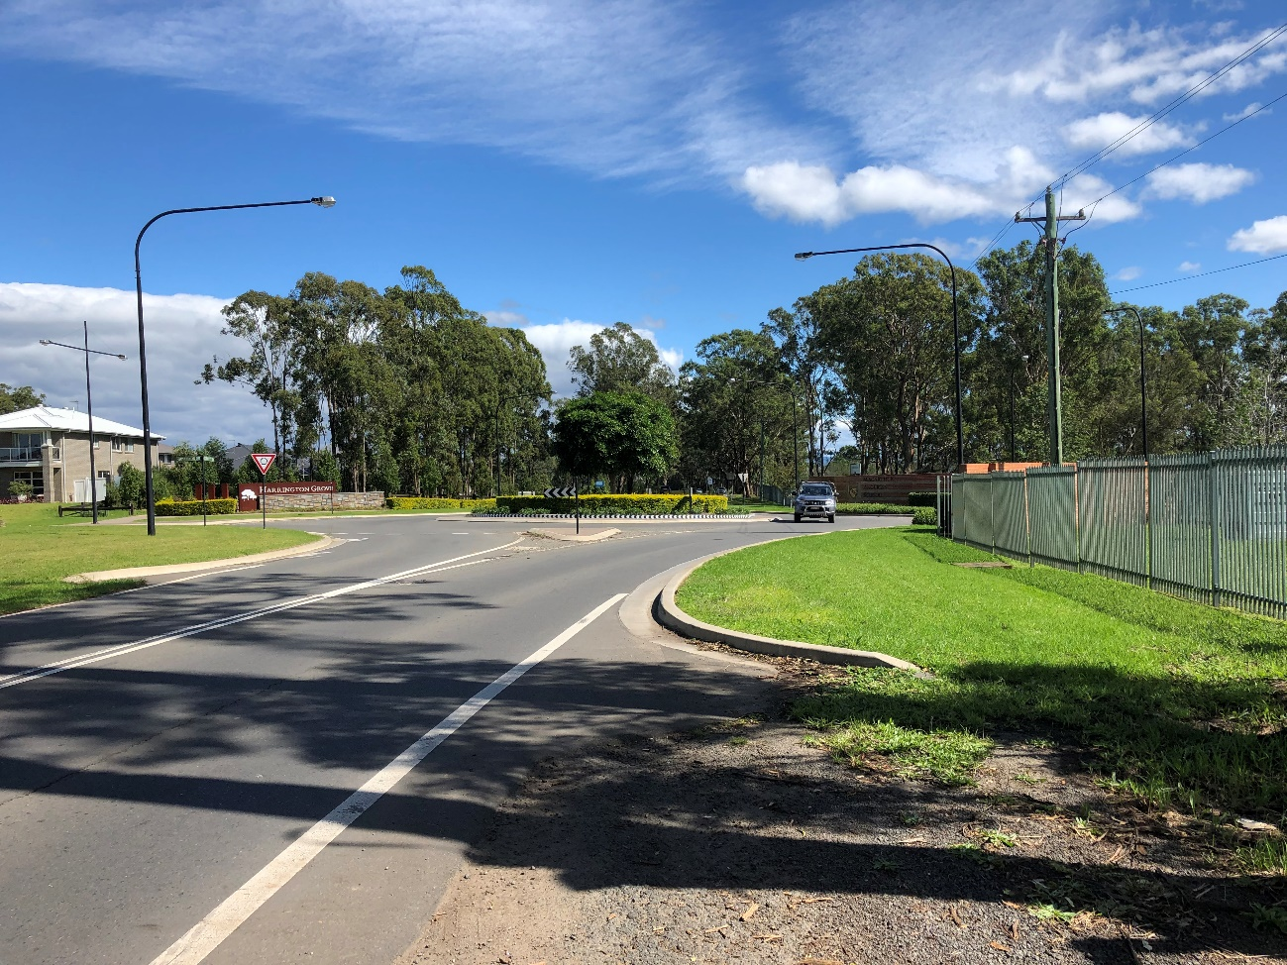
Figure 2: Looking west along Cobbitty Road towards the roundabout that services the entry and exit to Macarthur Anglican School.
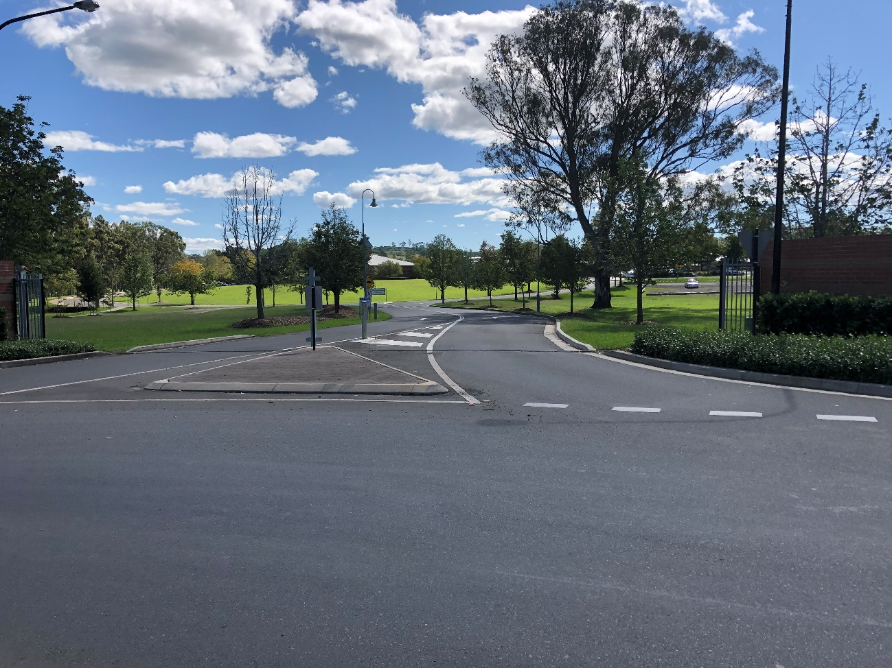
Figure 3: Looking north from the roundabout into the school site. The buildings to be demolished are not visible from the street.
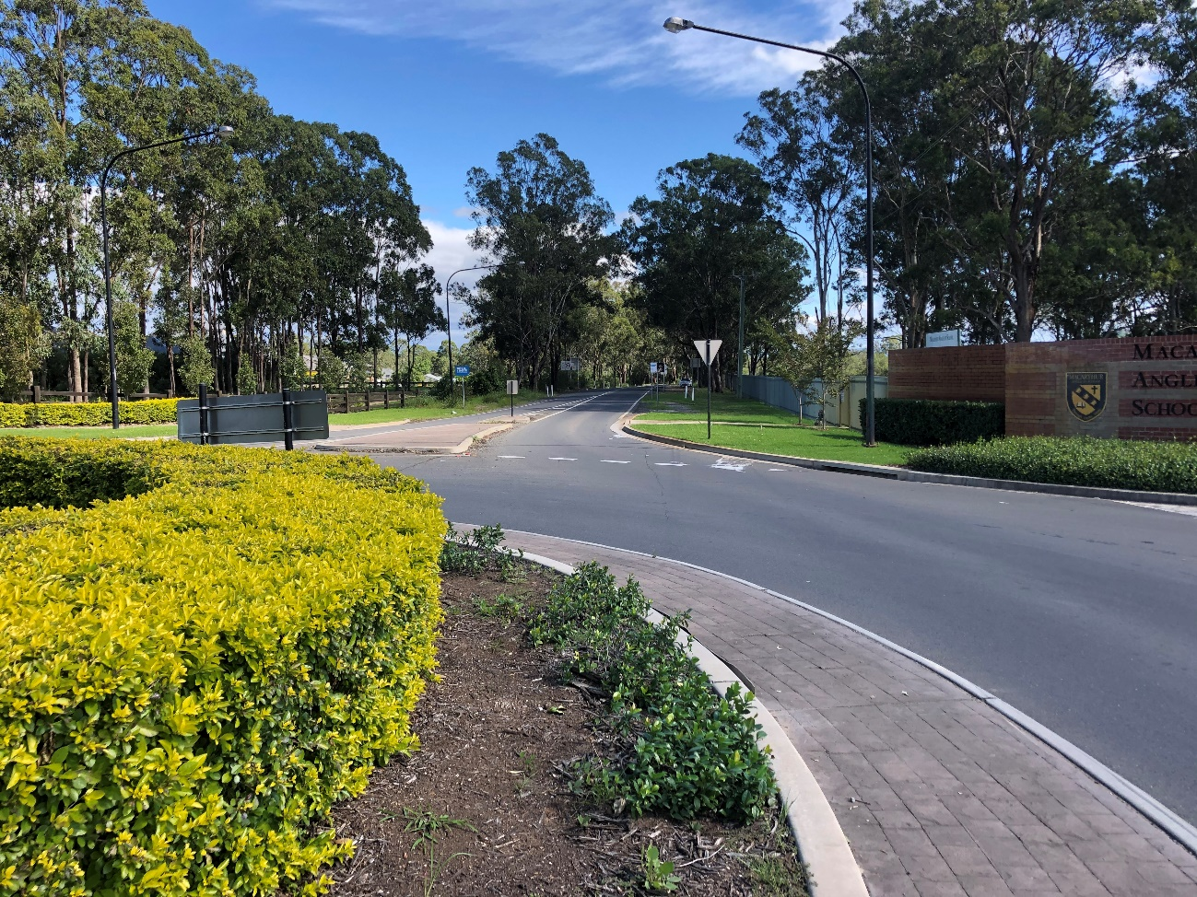
Figure 4: Looking west along Cobbitty Road from the roundabout.
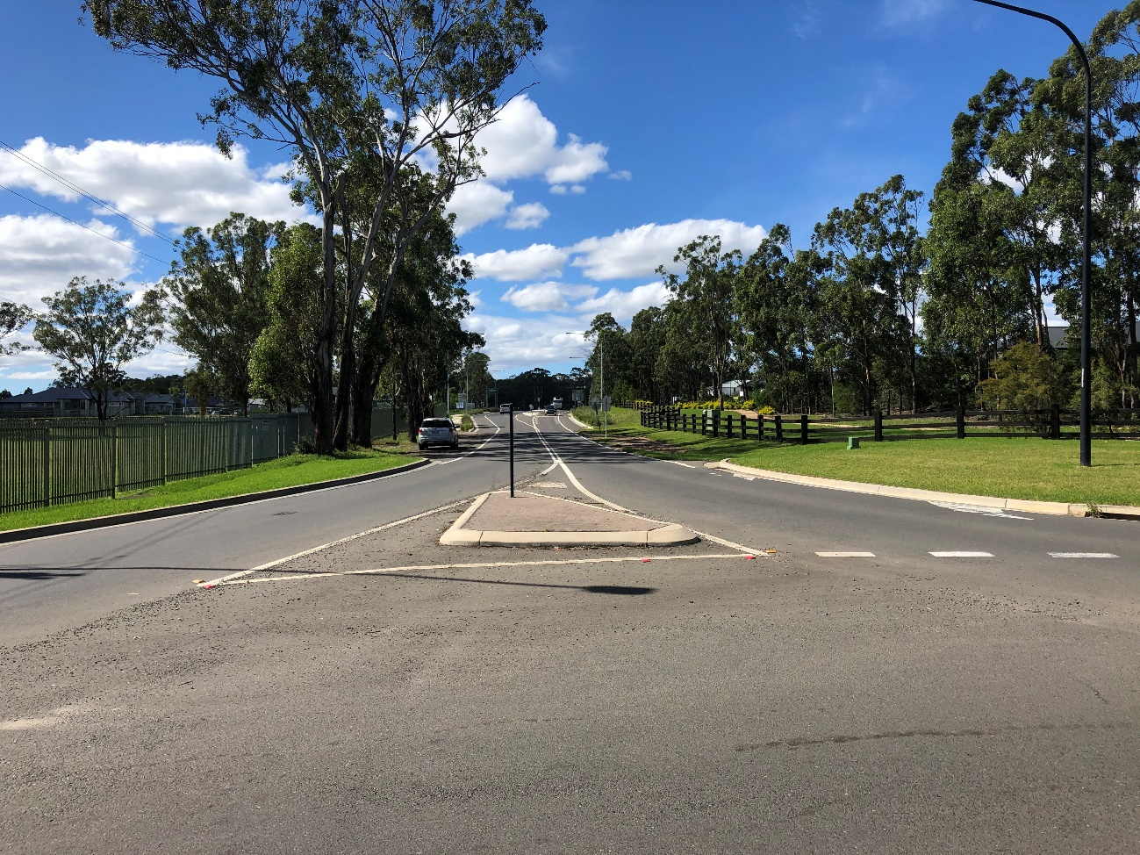
Figure 5: Looking east along Cobbitty Road from the roundabout.

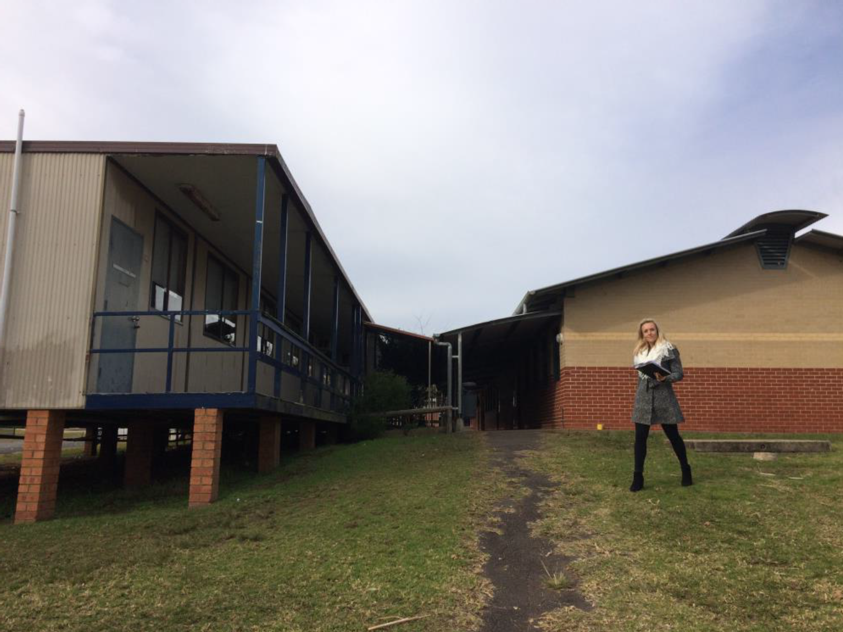
Figure 6: Existing science demountable (left) and science building (right)
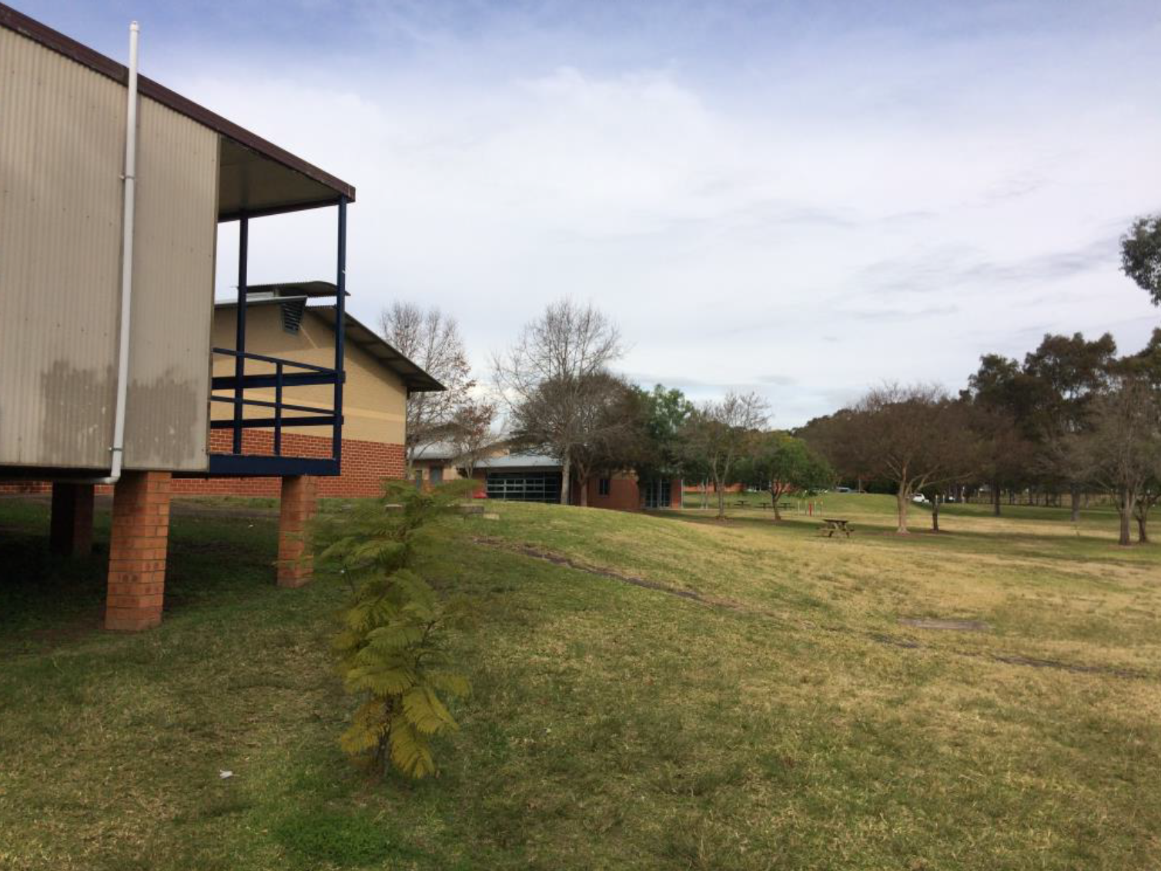
Figure 7: View of the existing science buildings (left) showing the topography of the site
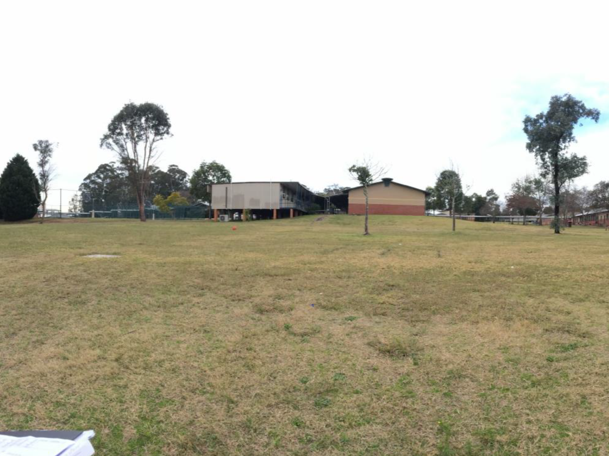
Figure 8: The development site, as viewed from the west.
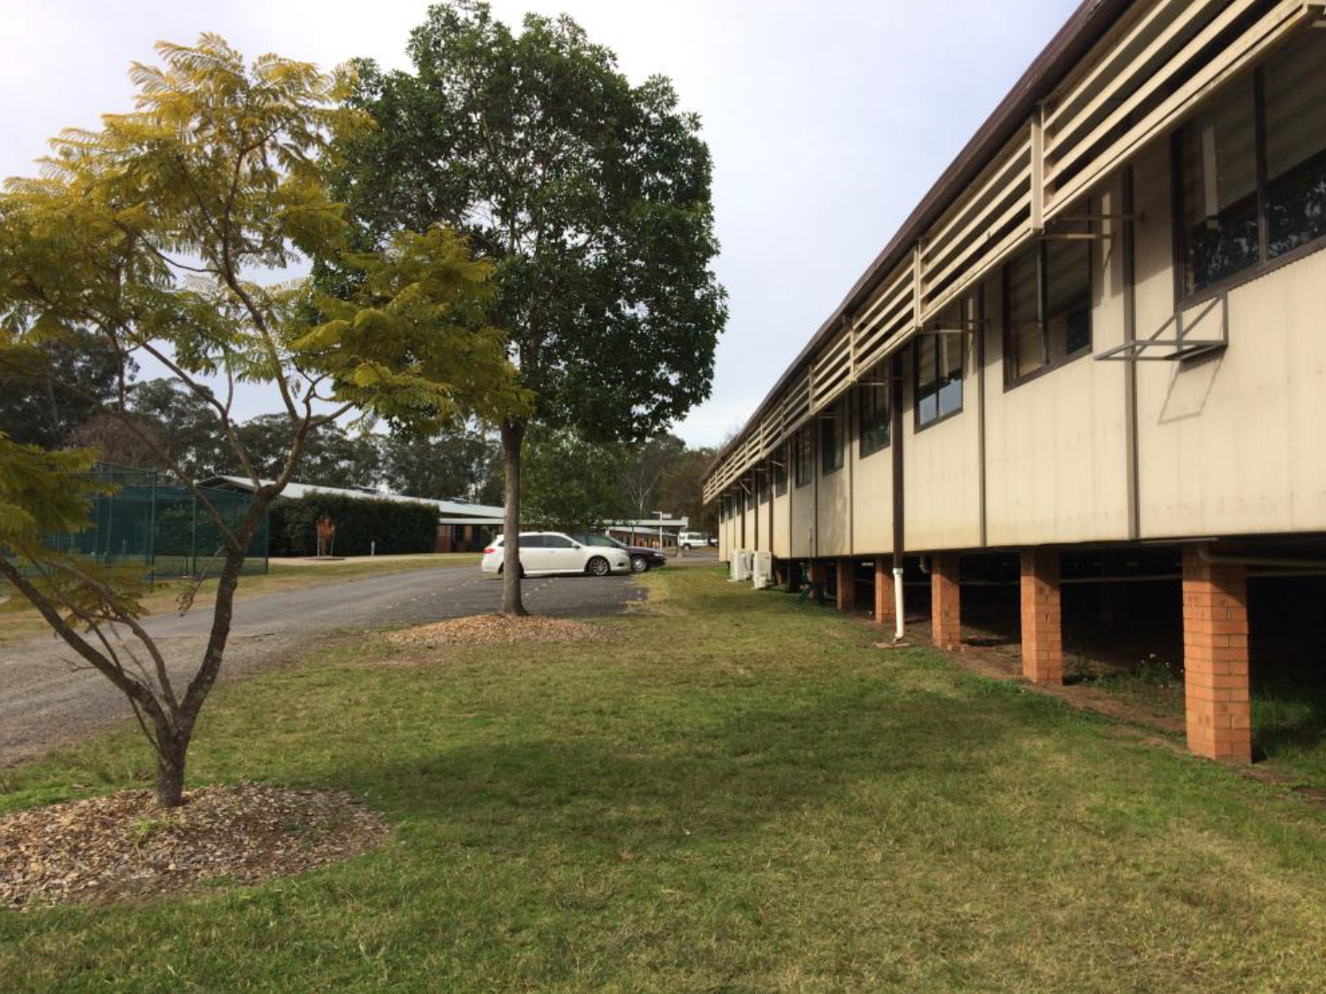
Figure 9: At-grade parking to the rear of the existing science demountable (right).
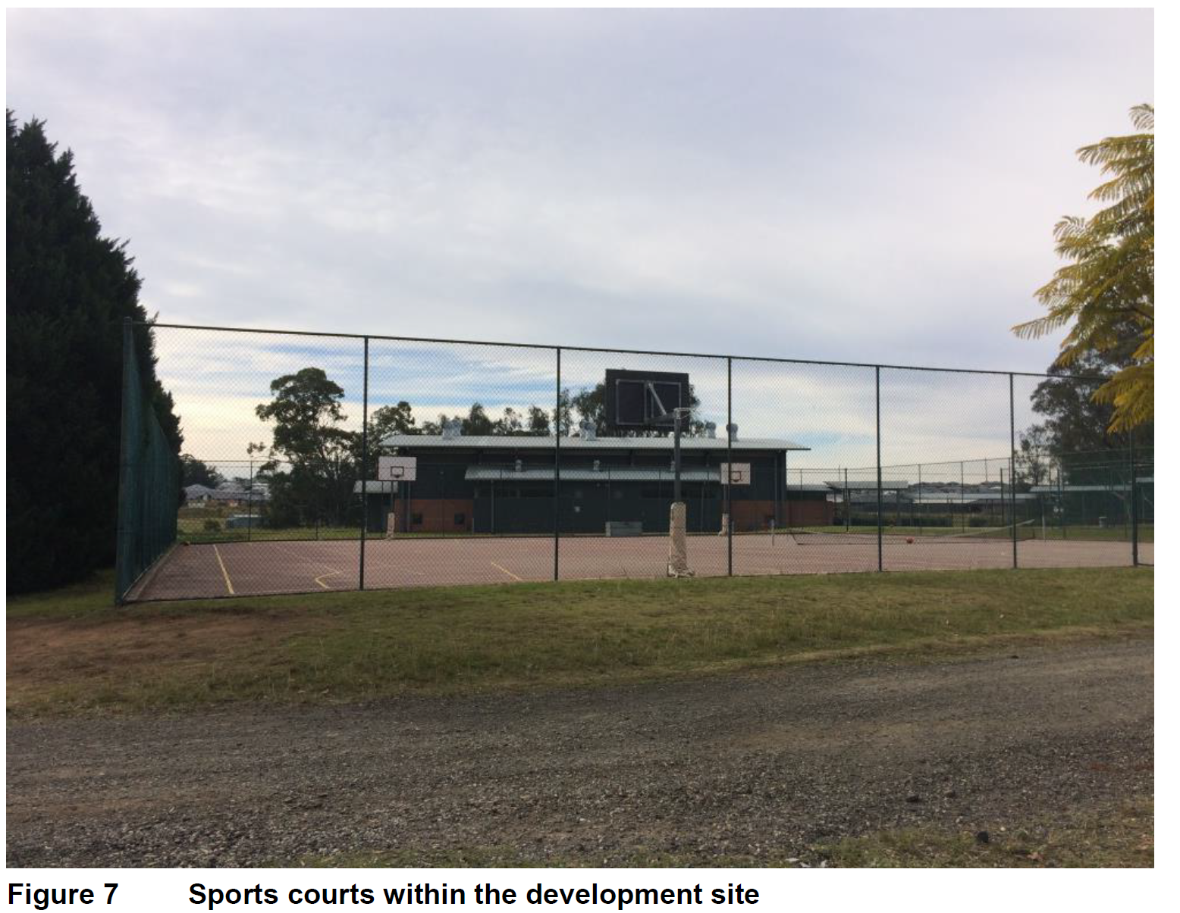
Figure 10: Sports courts within the development site
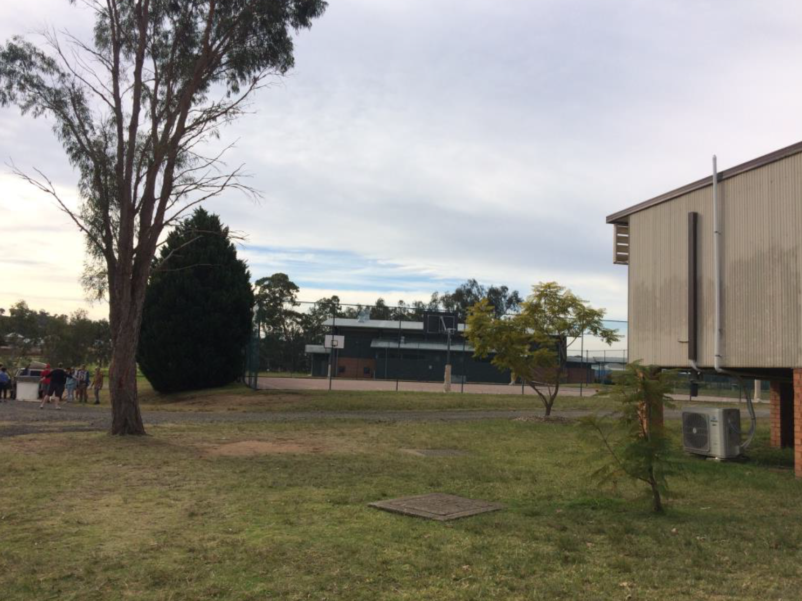
Figure 11: Existing science demountable (right) and sports courts in the background.

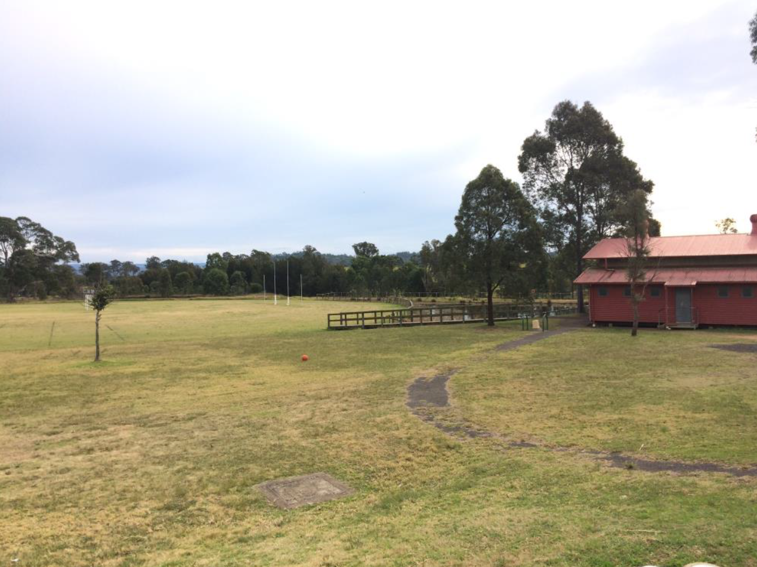
Figure 12: Development site in the foreground, with the playing fields in the background and PDHPE shed to the right.

